Math 8 Reveiw – Unit 6.4
- Writing and Solving Algebraic Expressions

6.4 – Writing and Solving Algebraic Expressions

Because many word problems make use of algebraic expressions, it is important to familiarize yourself with some of the language used to express algebra. For example;
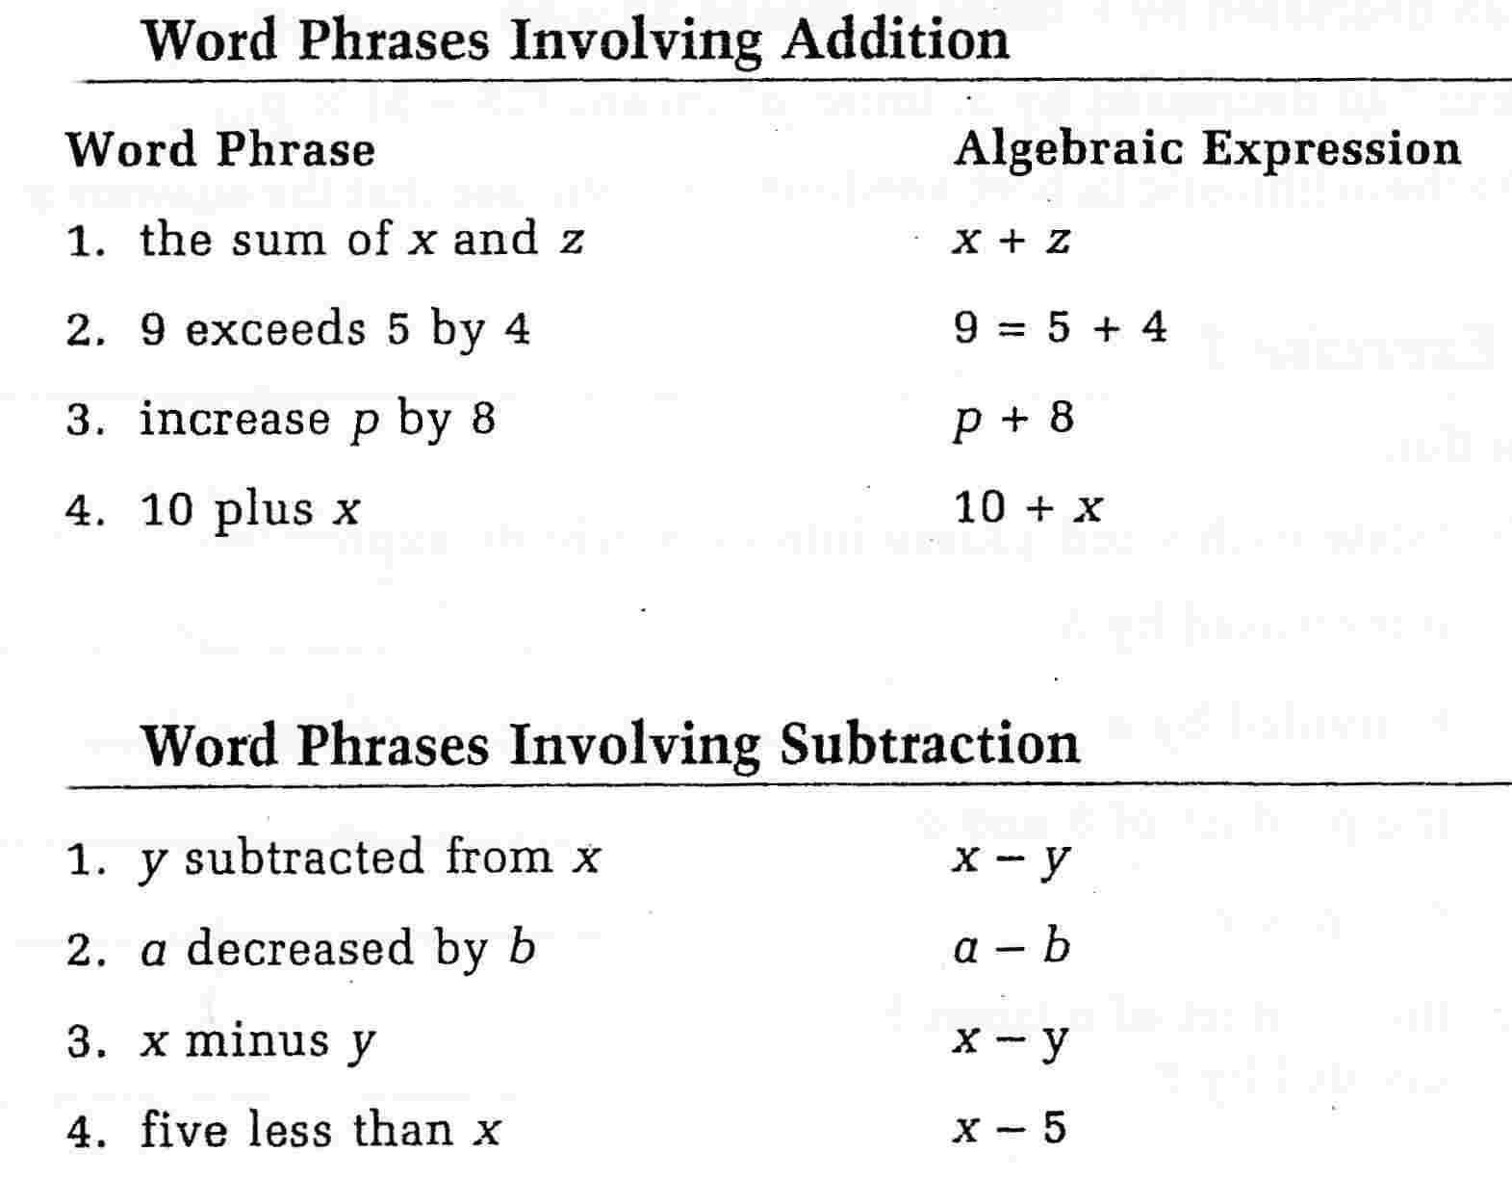

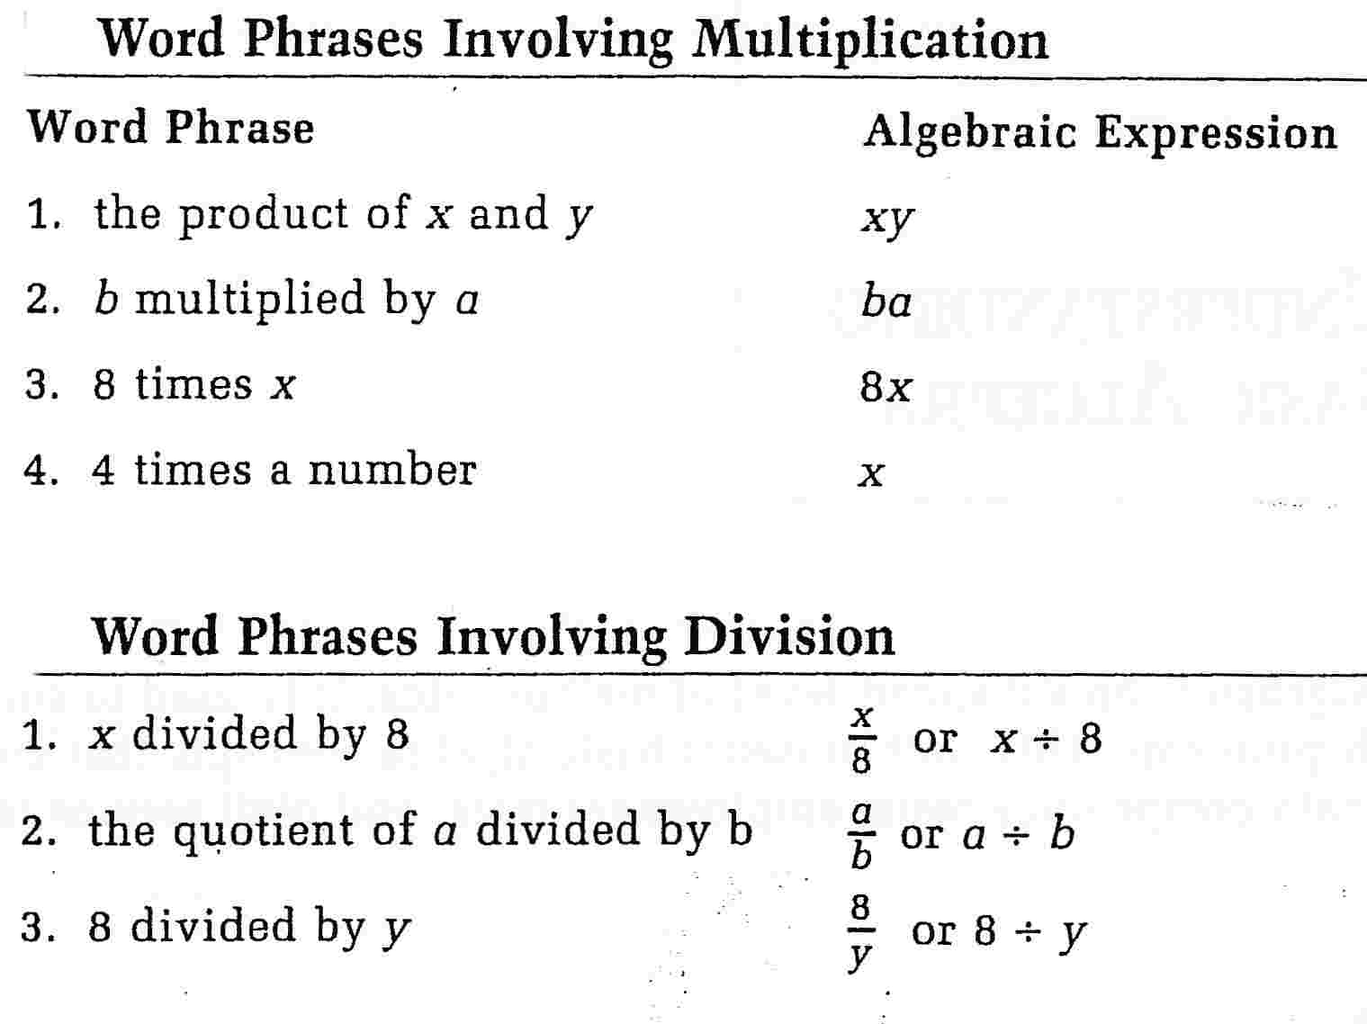

Your turn…

Directions: Translate each word problem into an algebraic expression. The first one has been done for you.
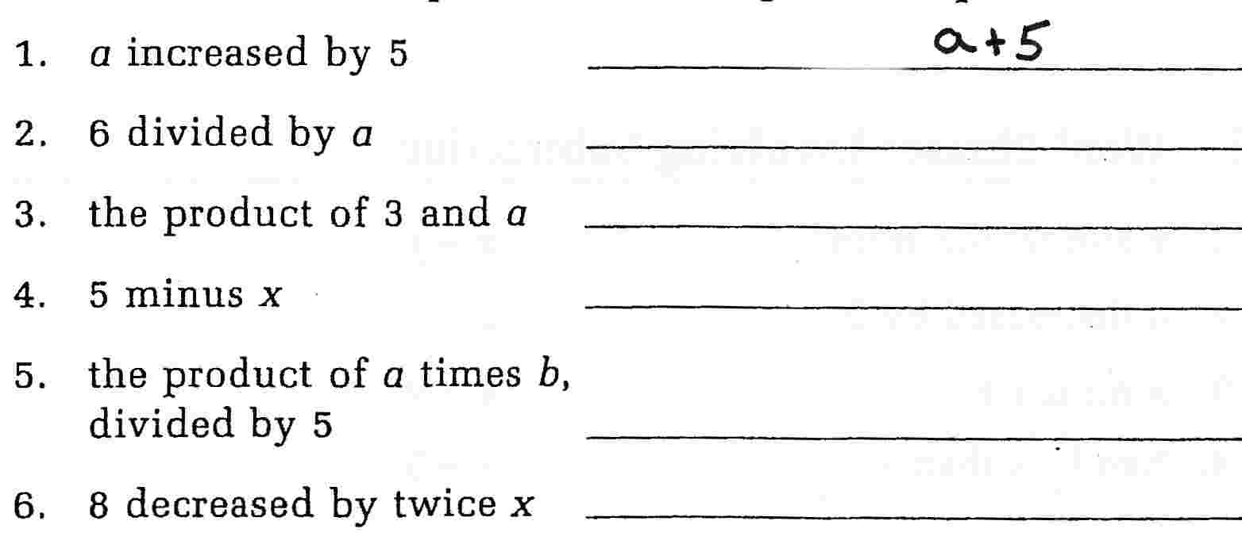

Directions: Read each algebraic expression and circle the letter of the answer that it describes.
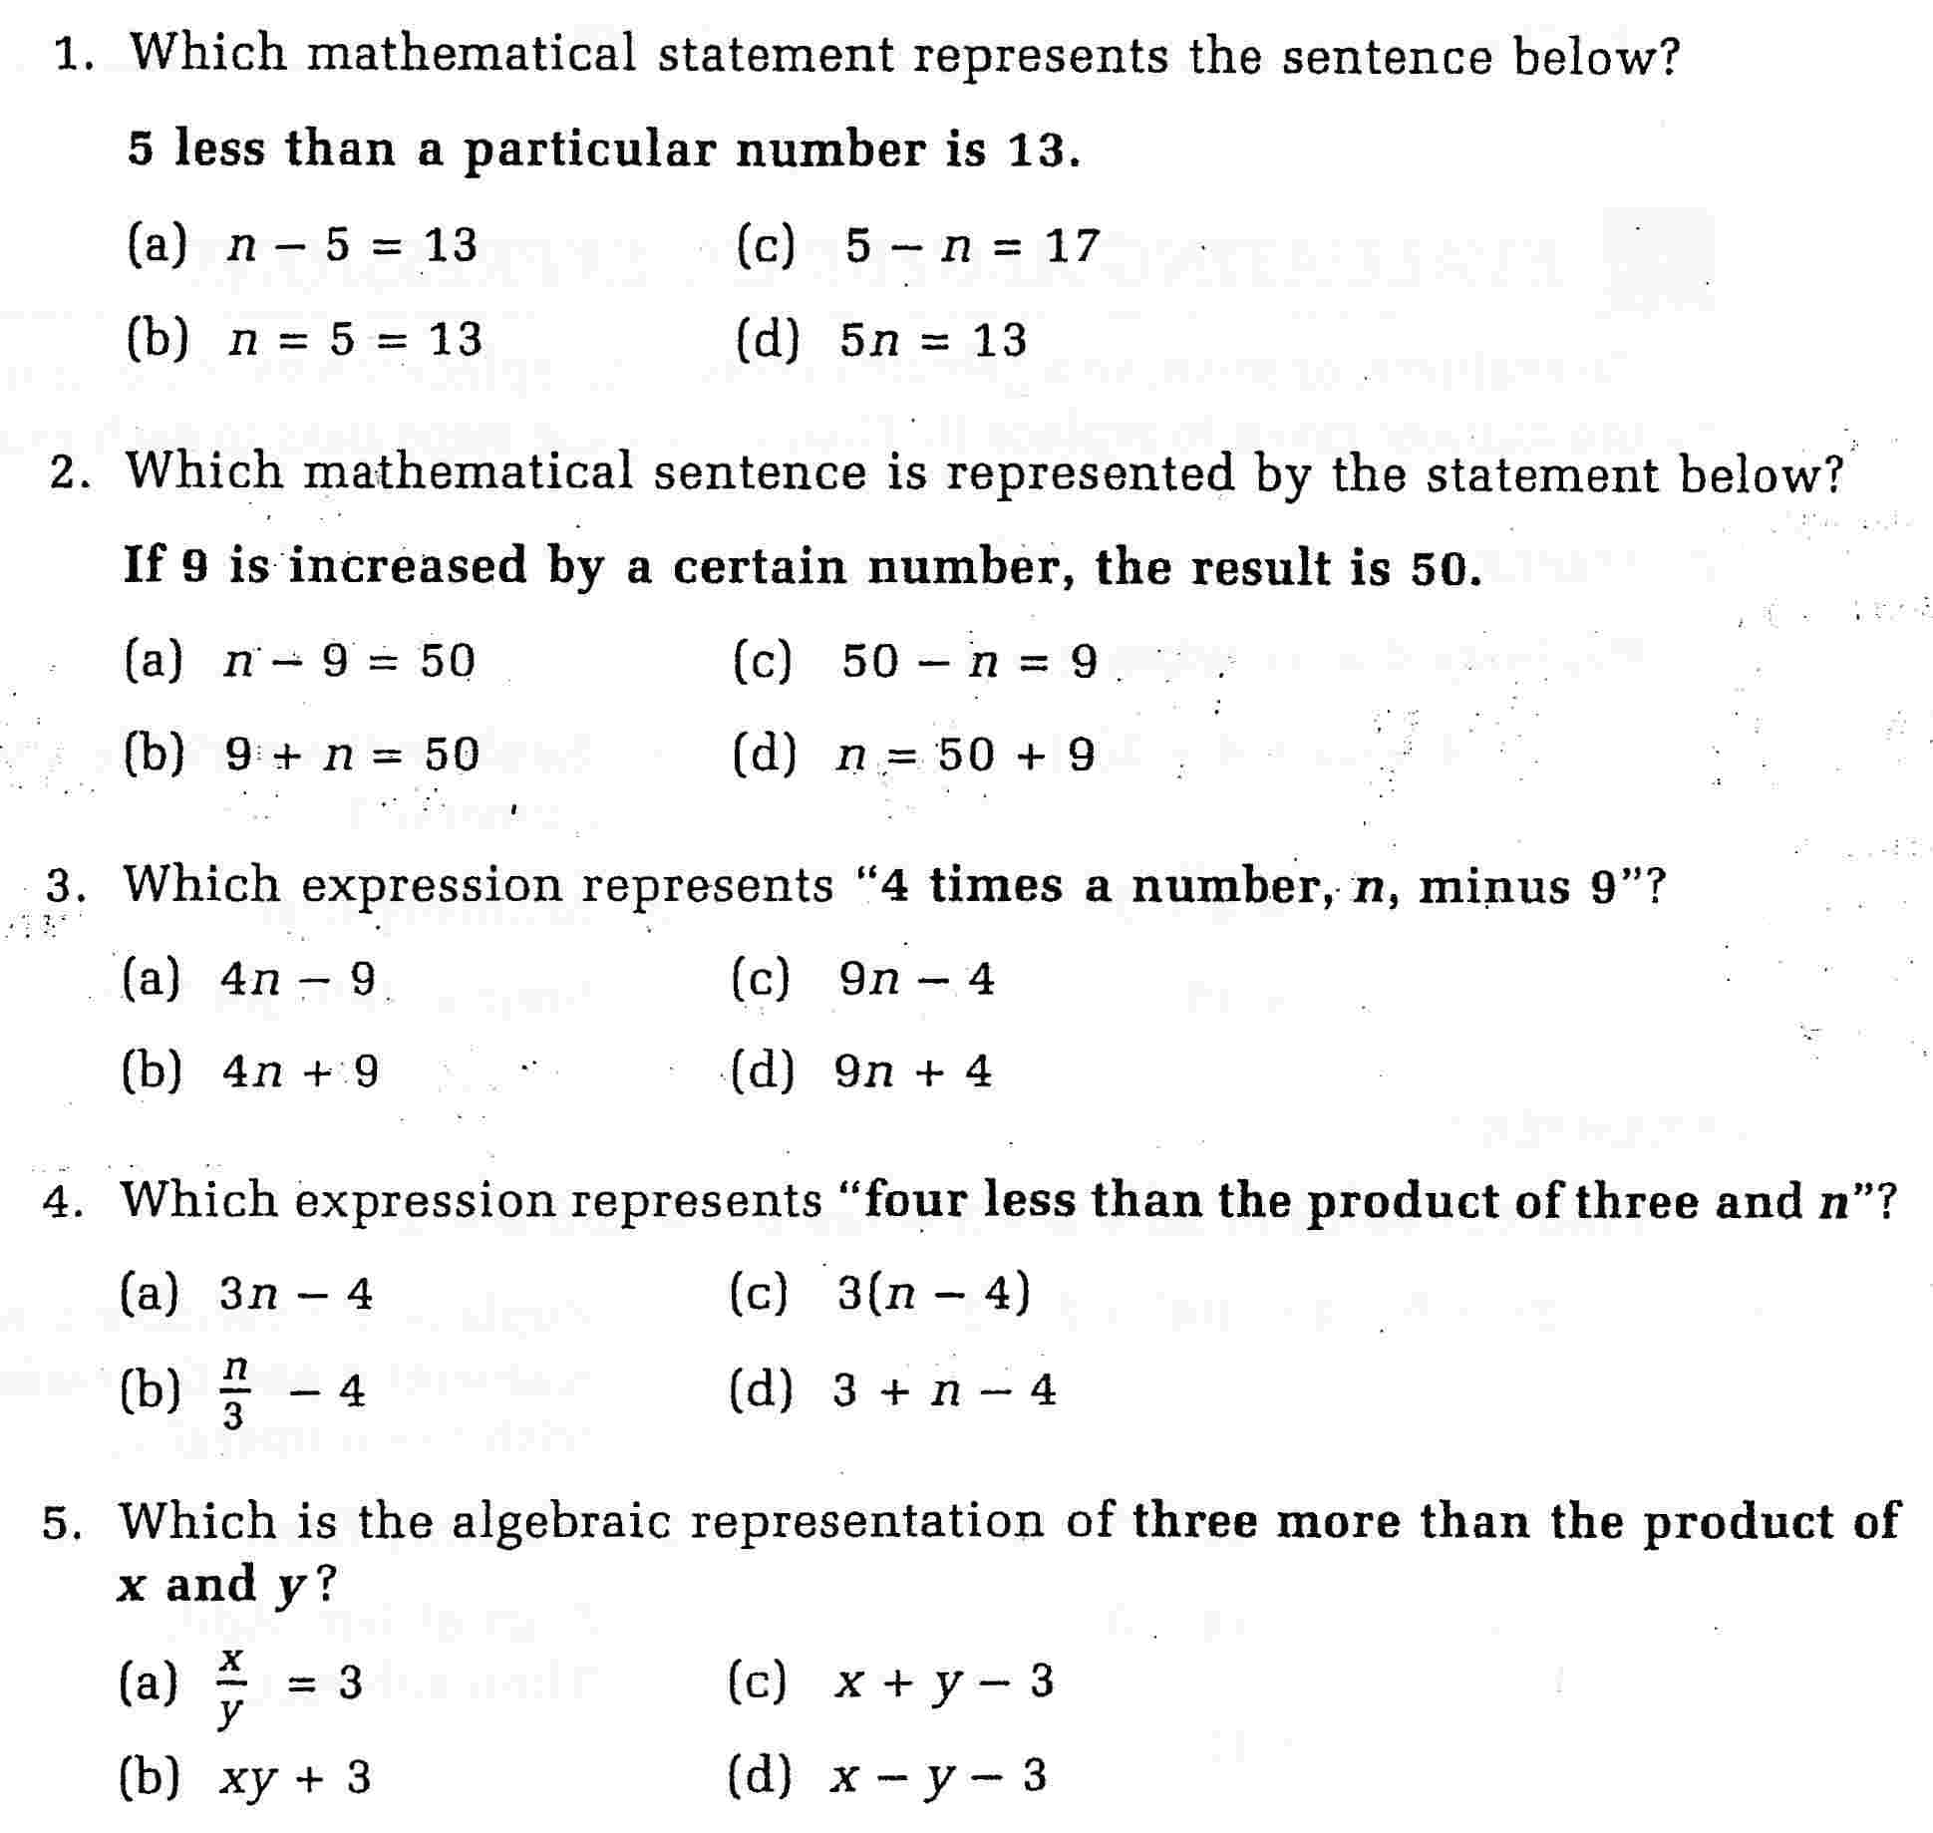

Directions: Solve each of the following questions as directed.

- Spencer gives 10 CDs to his brother. Now Spencer has 35 CDs left.

- Write an equation that you could use to find out how many CDs Spencer had to start with, and then solve the equation in an algebraic fashion SHOWING ALL YOUR WORK!!!

- Write an equation for each sentence, and then solve the equation in an algebraic fashion SHOWING ALL YOUR WORK!!!

- Seven more than a number is 18

- Six less than a number is 24

- Five times a number is 45

- A number divided by six is 7

- Three more than four times a number is 19

- Nevada bought 14 Justin Beiber DVDs for $182. Assuming that each DVD was the same price, what was the individual cost of each DVD?

- Jasmine collects beaded leather bracelets, after she lost 14 of them she had 53 left. How many did she have to start with?

- Ethan gets prize points for reading books. If he earns 100 points he gets a new game for his Wii game system. Right now, Ethan has 56 points, when he reads 11 more books he will have his 100 points. How many points is each book worth

Directions: Solve the following equations by showing all your work. The first two have been done for you.
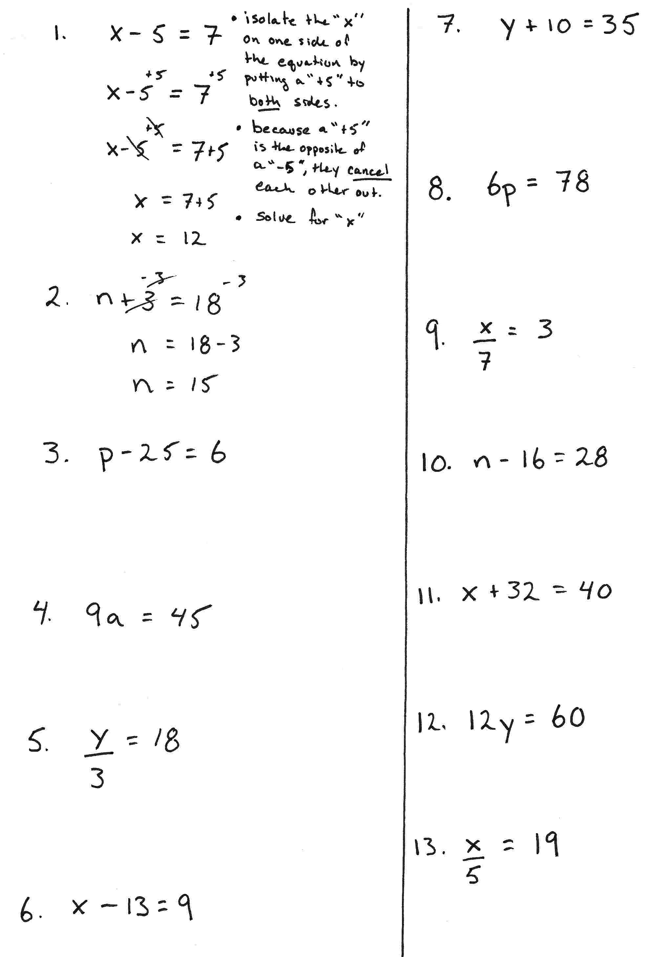

When solving two step equations where you have to “get rid” of a “plus or a minus” as well as a “times or a divided by”, it is often easiest to get rid of the “plus or minus” first, then solve by getting ride of the “times or divided by”.
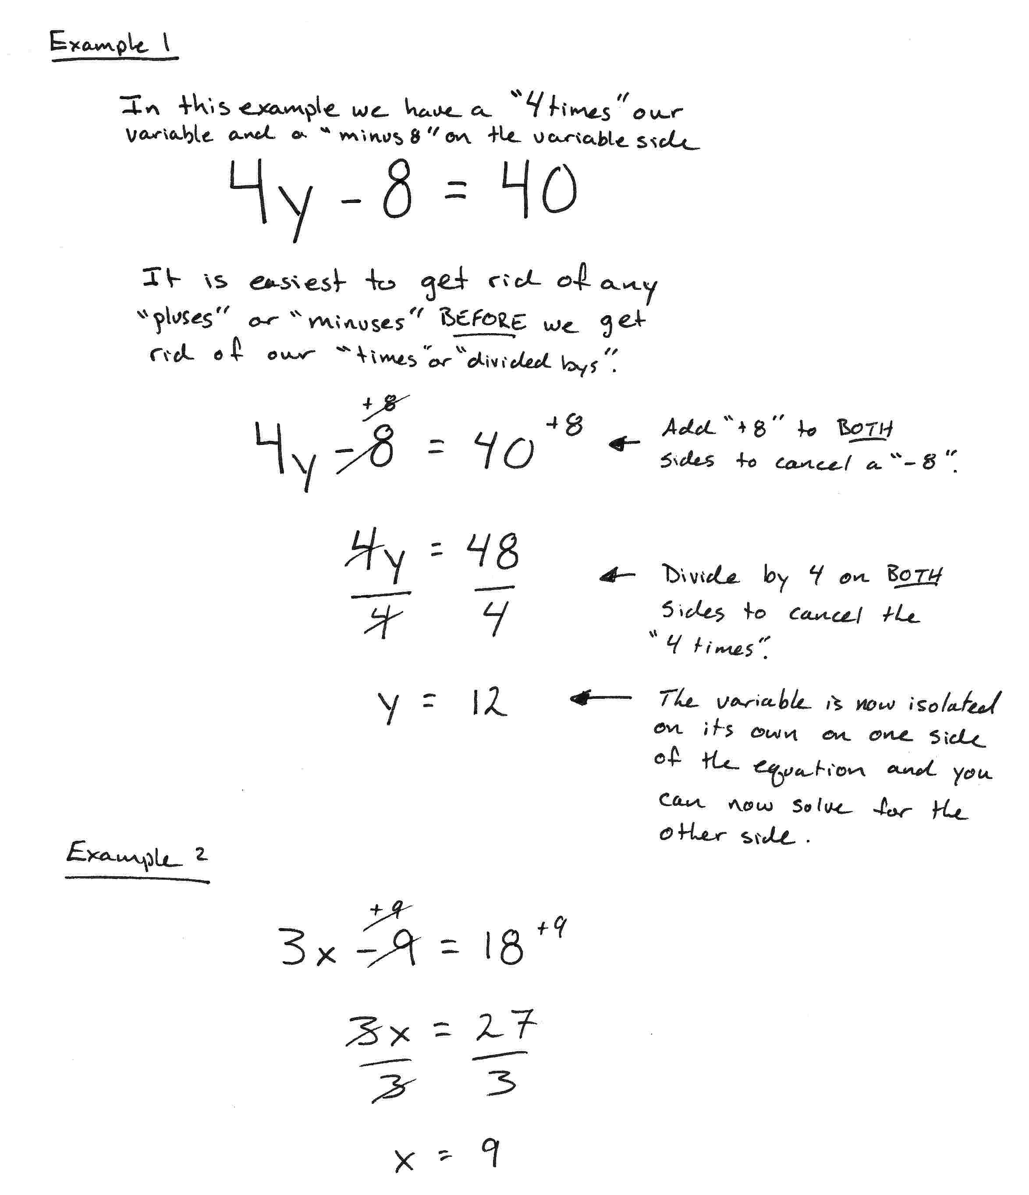

Your turn…

Directions: Solve. SHOW ALL YOUR WORK!!!!
